APPENDIX A

The STEM Interview Form

Dear students,
The questions in this form have been prepared to receive your views on the STEM activities we have carried out together. It is very important for the reliability of the information to be obtained that you answer the questions as detailed as possible. Thank you for your participation.

- Do you want to include such activities in your science courses? Explain why.
- What is the thing that affects you the most during the STEM activities? What are the positive or negative points of the STEM activities?
- In which parts of this activity are you challenged? Explain with your reasons.
- What skills can STEM education provide for students? Explain why.
- Are the engineering designs you have developed as a result of your work with STEM events important to you? Explain why.

APPENDIX B

Sample Scenario

Alarm System Design Activity: "Ahmet's Village Adventure"

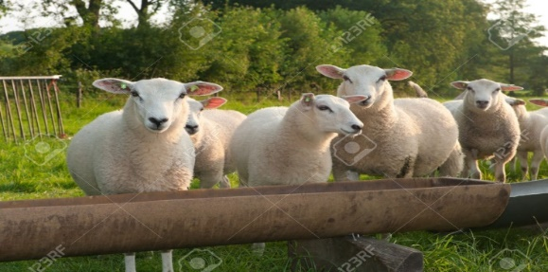
Ahmet, a middle school student, will go to grandfather’s home in the village for the summer vacation. His grandfather asks Ahmet to follow the water needs of the sheep. Ahmet promises that he will not neglect his mission. Ahmet wants to play with his friends in the village and wants to keep his promise. There he thinks that he must to design a simple electric circuit system that will warn that the water in the tank is exhausted. Therefore, he will have time to play with his friend in the village. In this regard, Ahmet decides to get help from the neighbor, Mustafa, an Electrical Engineer.

What kind of systems do you design if you are in Ahmet's place? Which one would you craft?

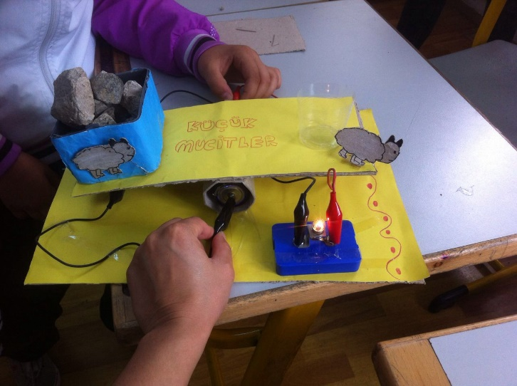
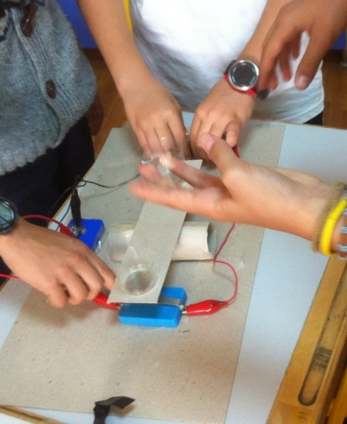
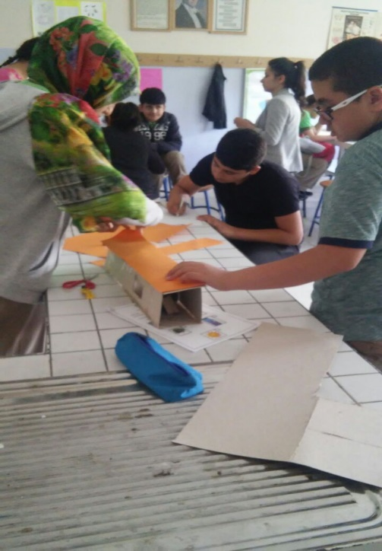
Examples from student work:

