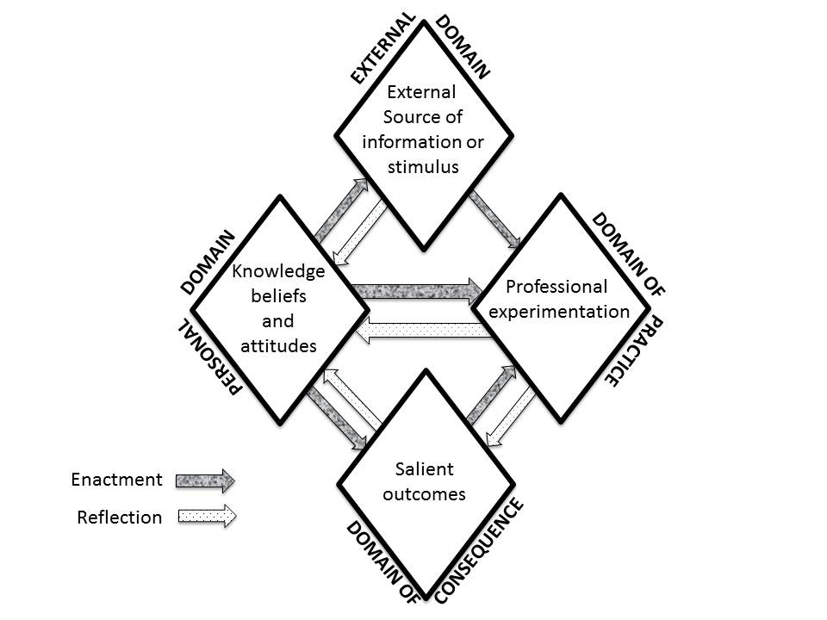

Figure 1. A graphical depiction of the Interconnected Model of Teacher Professional Growth (Clarke & Hollingsworth 2002)

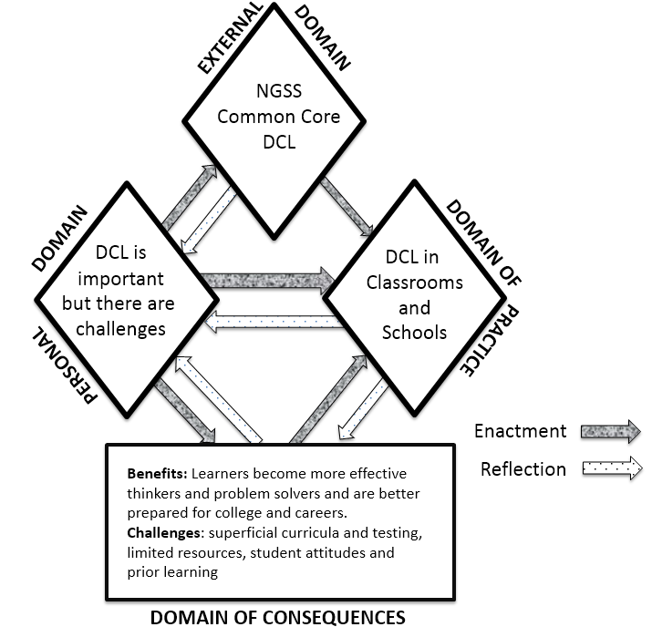

Figure 2. Domains of the Interconnected Model of Teacher Professional Growth related to DCL.

