Classification of End-of-Chapter Questions in Senior School Chemistry Textbooks used in [Country]
By
Authorª* & Co-author^{b}
^{a, b}Department of Science Education, University of [City], [City], [Country]
*Corresponding author: mail@yahoo.com
Supplementary Materials
The classified and analyzed end-of-chapter questions were three selected chemistry textbooks commonly used in [Country]. Table 5 presents the supplementary materials of the chapters analyzed, alongside labels assigned to each of the chapters for reference purposes. All the questions analyzed in each of the chapters were only essay questions. For questions with multiple parts, each part was taken as a single question that was coded, classified and analyzed.
Figures 3 (a-f) in the supplementary materials present the distribution of the questions according to the cognitive process and knowledge dimensions for each of the chapters analyzed in the New School, Comprehensive and Essential Chemistry Textbooks. The assigned labels correspond with the topics in Table 5. The graphs show differences and similarities in the end-of-chapter questions in each of the chapters and the selected chemistry textbooks.

Table 5
Chapters of Textbooks Analyzed and the Assigned Labels
Comprehensive Chemistry by [Author] | Essential Chemistry by I.A [Author] | New School Chemistry by [Author] | Label
Introduction To Chemistry | – | Introduction to Chemistry | IC
Nature of Matter and Separating Techniques | Nature Of Matter and Separation Techniques | Nature Of Matter and Separation Techniques | MST
Formulae and Valency | Symbols, Formulae and Equations | Atoms, Moles, Formulae and Equations | FV
Particulate Nature Of Matter | Particulate Nature of Matter | – | PNM
Chemical Laws And Chemical Combination | Orbitals, Electronic Structure of Atom and Chemical Combination | Atomic Structure and Chemical Combination | CC
Kinetic Theory and State Of Matter | Kinetic Theory of Matter and Gas Laws | Kinetic Theory of Matter and Gas Laws | KT
Acids, Bases and Salts | Acids, Bases and Salts | Acids, Bases and Salts | ABS
Carbon and its Compounds | Carbon and its Compounds | Carbon and its Compounds | C
Hydrocarbons and Industrial Chemistry | Hydrocarbons, Crude Oil and Industrial Chemistry | Hydrocarbons, Crude Oil and Industrial Chemistry | HIC
The Periodic Table and Periodicity Of Properties of Elements | Periodic Table | Periodic Table and Families of Elements | PT
Electrical Nature of Chemical Substances | Electrolysis | Electrode Potentials, and Electrolysis | E
Types of Reaction | Oxidation and Reduction | Types of Reaction, Oxidation and Reduction | TR
Energy Changes in Chemical Reactions | Energy and Chemical Reactions | Energy and Chemical Reactions | ECR
Rates of Reaction | Chemical Reaction | Rates of Reaction | RR
Air and Pollution | Air and Air Pollution | Air and Air Pollution | AP
Water and Solution | Water, Solution and Solubility | Water, Solution and Solubility | WS
Hydrogen | Hydrogen and its Compounds | Hydrogen and Hydrides | H
Oxygen and its Compounds | Oxygen and its Compounds | Oxygen and its Compounds | O
Sulphur and its Compounds | Sulphur and its Compounds | Sulphur and its Compounds | S
Halogens and their Compounds | The Halogens | The Halogen Family | HF
Nitrogen and its Compounds | Nitrogen and its Compounds | Nitrogen and Its Compounds | N
Introduction to Organic Chemistry | Organic Chemistry (I) | Organic Chemistry (I) | OC(I)
Alkanols, Alkanoic, Alkanoates, Carbohydrates and Giant Molecules | Organic Chemistry (II) | Organic Chemistry (II) | OC (II)
Metals and their Compounds | Metals and Their Compounds (I) | Metals and their Compounds (I) | MC
Transition Metals | Metals and Their Compounds(II) | Metals and their Compounds (II) | TM
Radioactivity | Nuclear Chemistry | Radioactivity and Nuclear Chemistry | R
– | Mass Volume Relationships in Reaction | Volumetric and Qualitative Analysis | V
– | Chemical Equilibrium | Chemical Equilibrium | CE

Figure 3 (a-f). Classification of questions in the categories of the cognitive process skills and the knowledge dimensions for each of the analyzed chapters of Comprehensive, Essential and New school chemistry textbooks. The assigned labels correspond to each of the chapters presented in Table 5 of the supplementary materials.
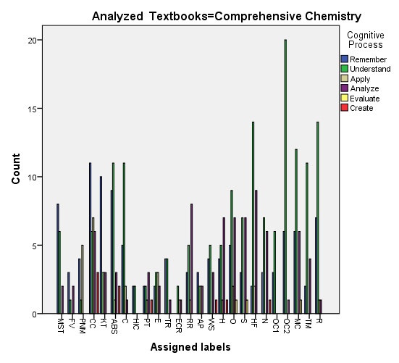
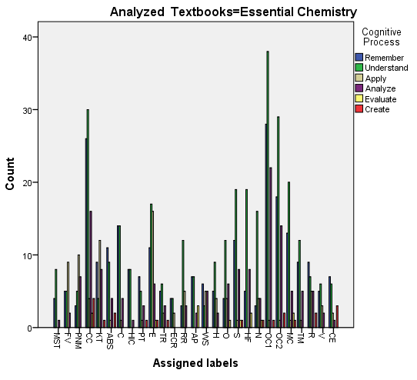
(a) Comprehensive chemistry Textbook
(b) Essential Chemistry Textbook

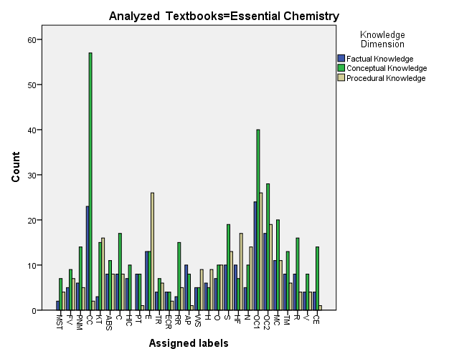
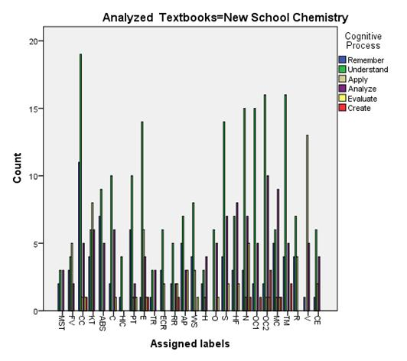
(c) New School Chemistry Textbook (d) Essential Chemistry Textbook

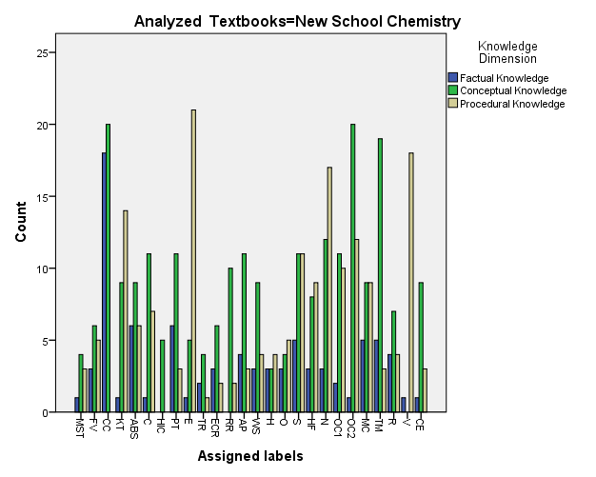
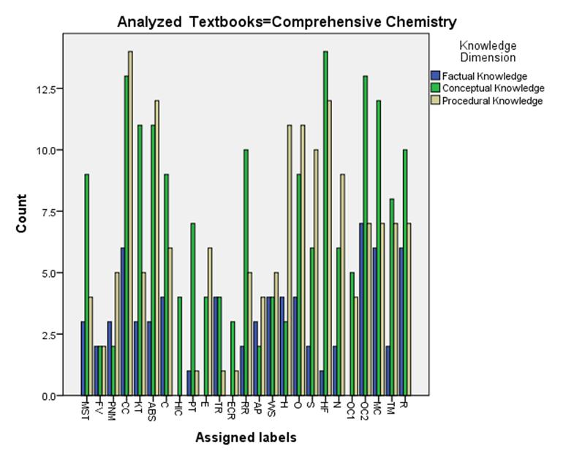 (e) Comprehensive Chemistry Textbook
(f) New School Chemistry Textbook

